**CS469 Data Structures and Algorithms**

**HOS00A –Visual Studio Code (VS Code)**

3/29/2023 Reviewed by Christopher Sharp

01/04/2024 Reviewed by Anh Nguyen

09/25/2024 Reviewed by Shahid Khan

School of Technology and Computing (STC) @City University of Seattle (CityU)



**Before You Start**

* If you already finished this module through other CityU School of Technology and Computing (STC) courses, feel free to skim this activity. But verify VSCode installation on your computer.
* Version numbers may not match with the most current version at the time of writing. If given the option to choose between stable release (long-term support) or most recent, please choose the stable release rather than beta-testing version.
* This tutorial targets Windows users and MacOS users.
* There might be subtle discrepancies along the steps. Please use your best judgement while going through this cookbook style tutorial to complete each step.
* For your working directory, use your course number. This tutorial may use a different course number as an example.

**Learning Outcomes**

* Installing VS Code
* Making your development directory

**1. Installing Visual Studio Code**

**1.1. Windows**

Installation

1. Visit <https://code.visualstudio.com/>

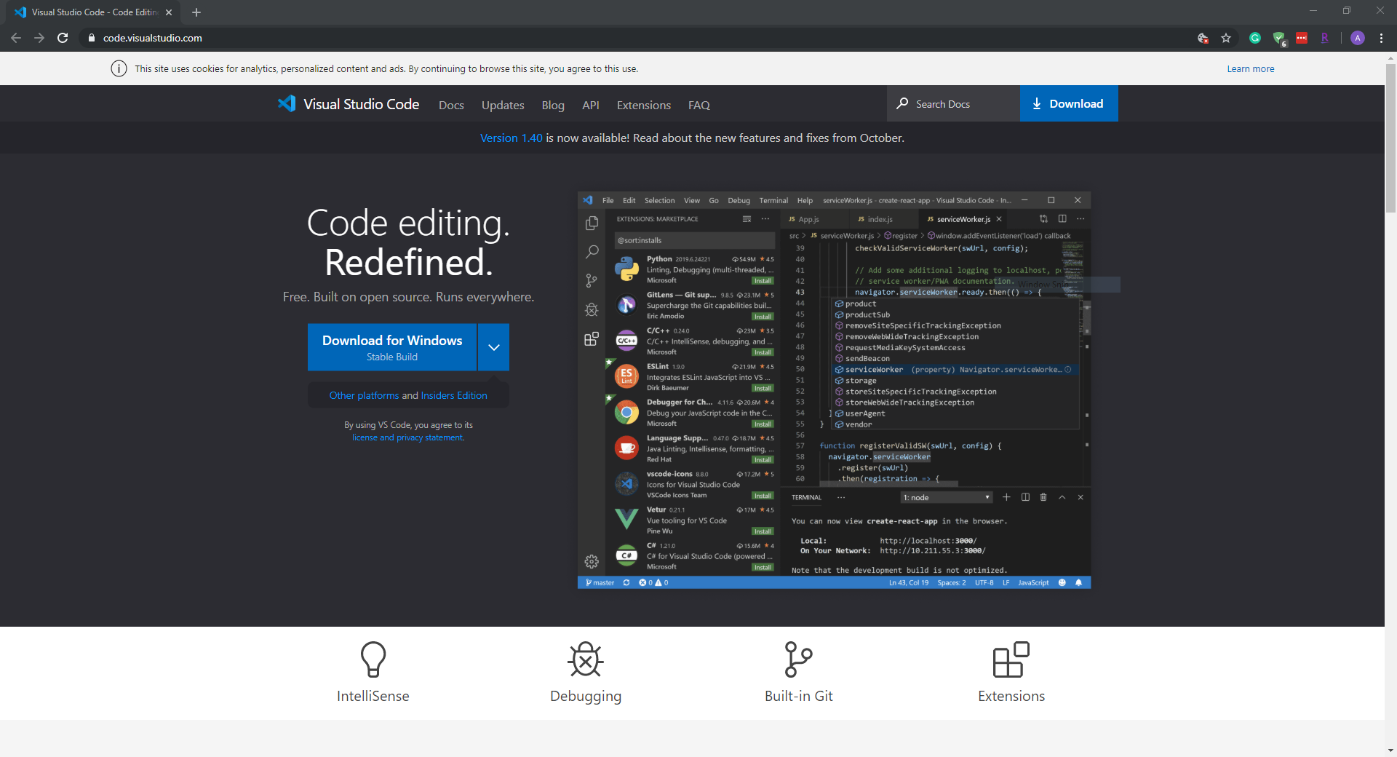

Select the correct version for your operating system and download it.  
For example, you can download “VSCode-darwin-universal” for your Mac. (As of March 2023)

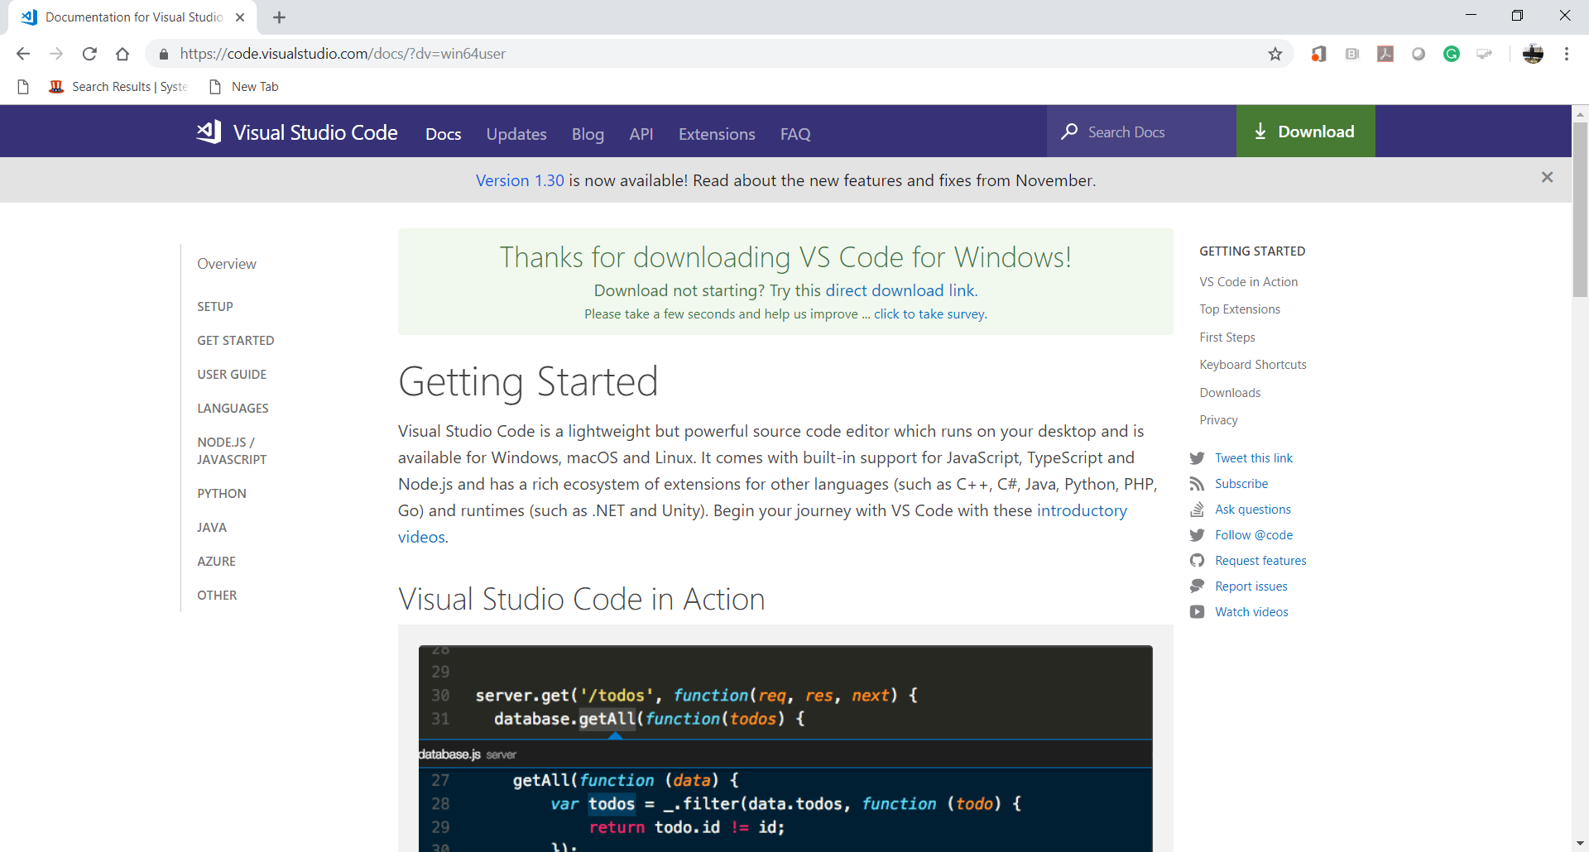

1. Install VSCode. Follow the instructions. If you’re running into issues, first consult Microsoft’s documentation [here](https://code.visualstudio.com/docs/setup/setup-overview).

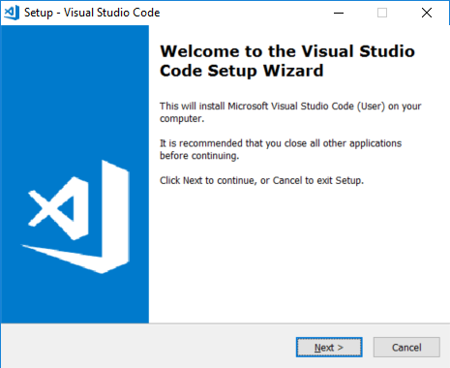

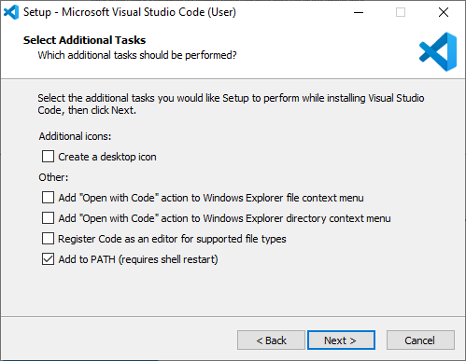

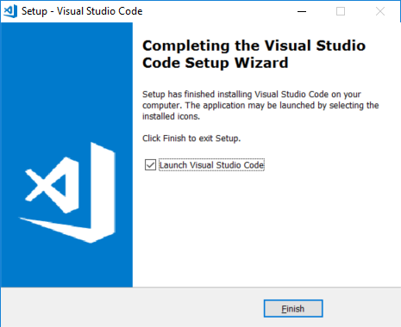  
  
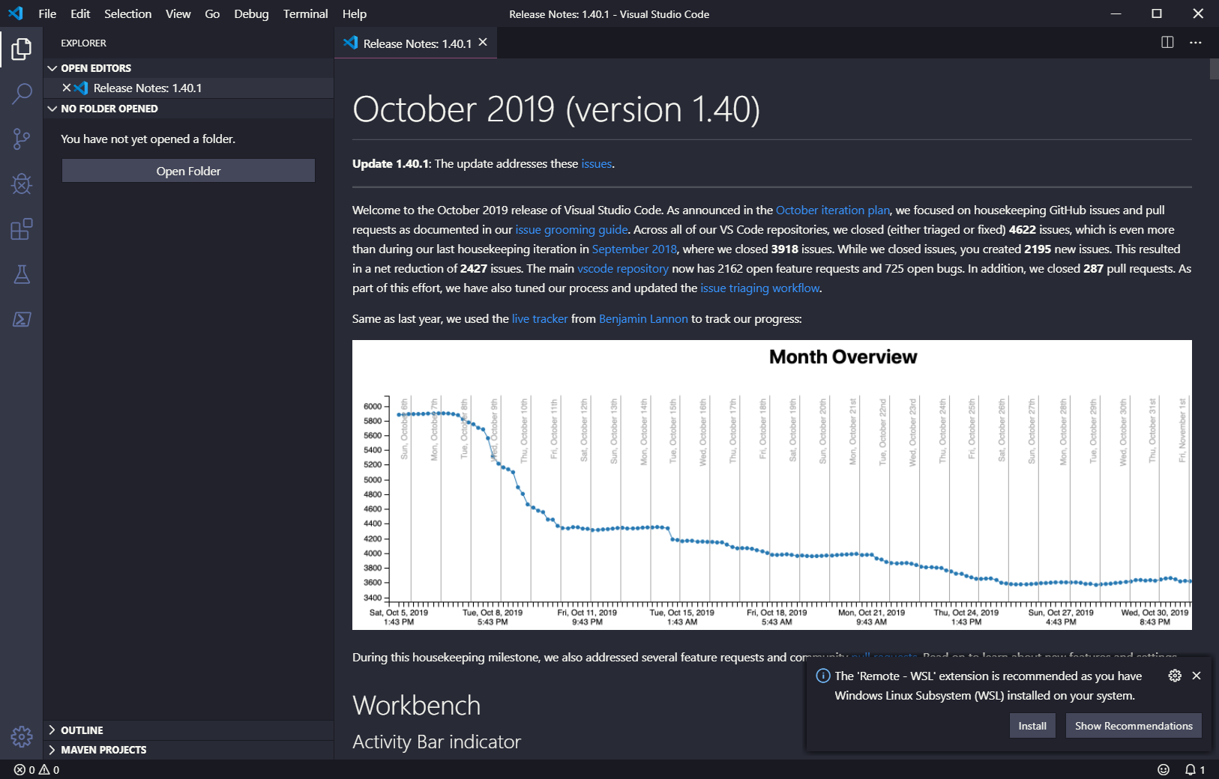

1. After installing the VSCode, close the opened VSCode.  
   Go to “File” menu end select ‘Exit” menu item.

**1.2. macOS**

Installation is the same as above except when you unzip the file, you just need to manually move it to your Applications folder. (Copy and paste, then delete the original.)

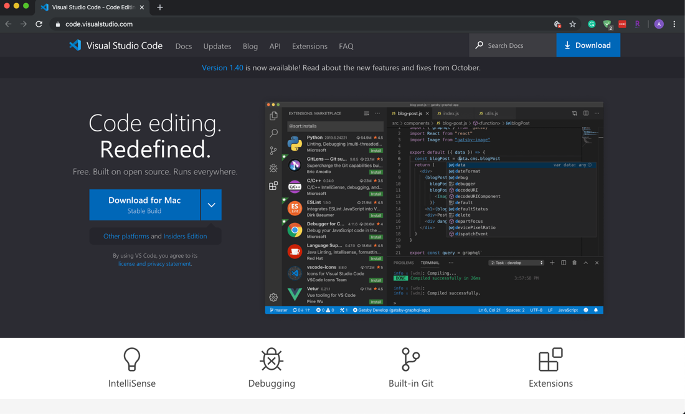

Launching from the command line

(You can also run VS Code from the terminal by typing 'code' after adding it to the path)

* Launch VS Code.
* Open the Command Palette (F1) and type 'shell command' to find the Shell Command: Install 'code' command in PATH command.

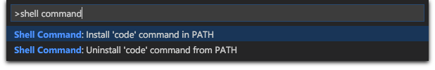

* Restart the terminal for the new $PATH value to take effect. You'll be able to type 'code .' in any folder to start editing files in that folder.

**2. Making your development directory**

1. Open the VSCode again.
2. Go to “View” menu and select “Terminal” menu item for your Command Line Interface (CLI).

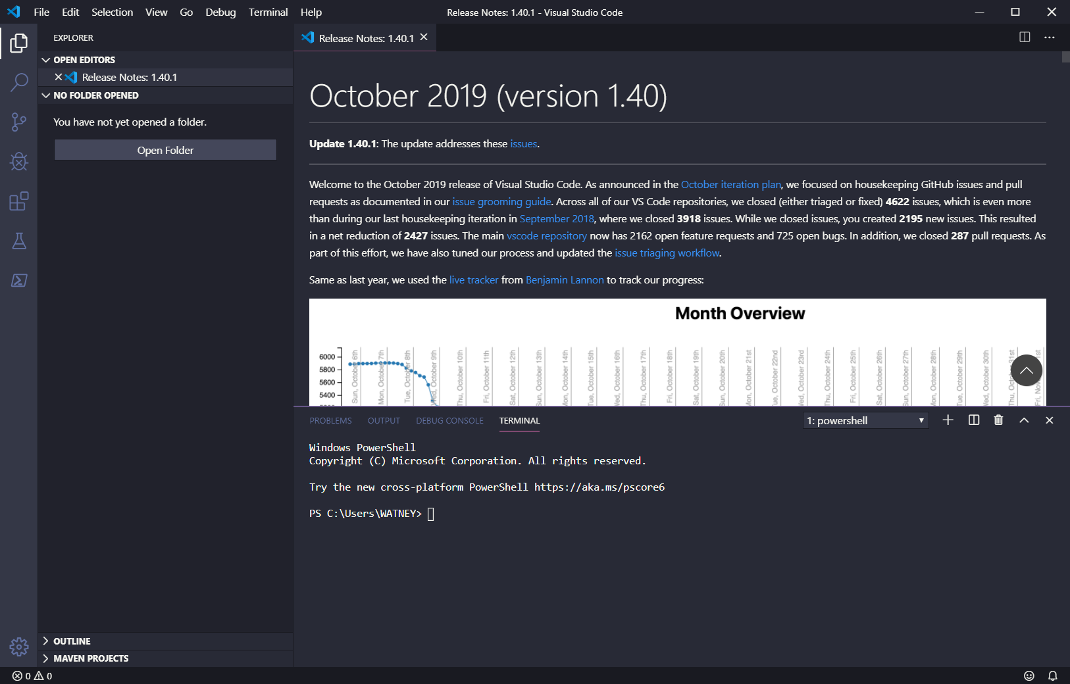

1. Go to the location you like to save the work (e.g., home directory by typing **cd** in the terminal).

We will clone the directory from GitHub in the next session.

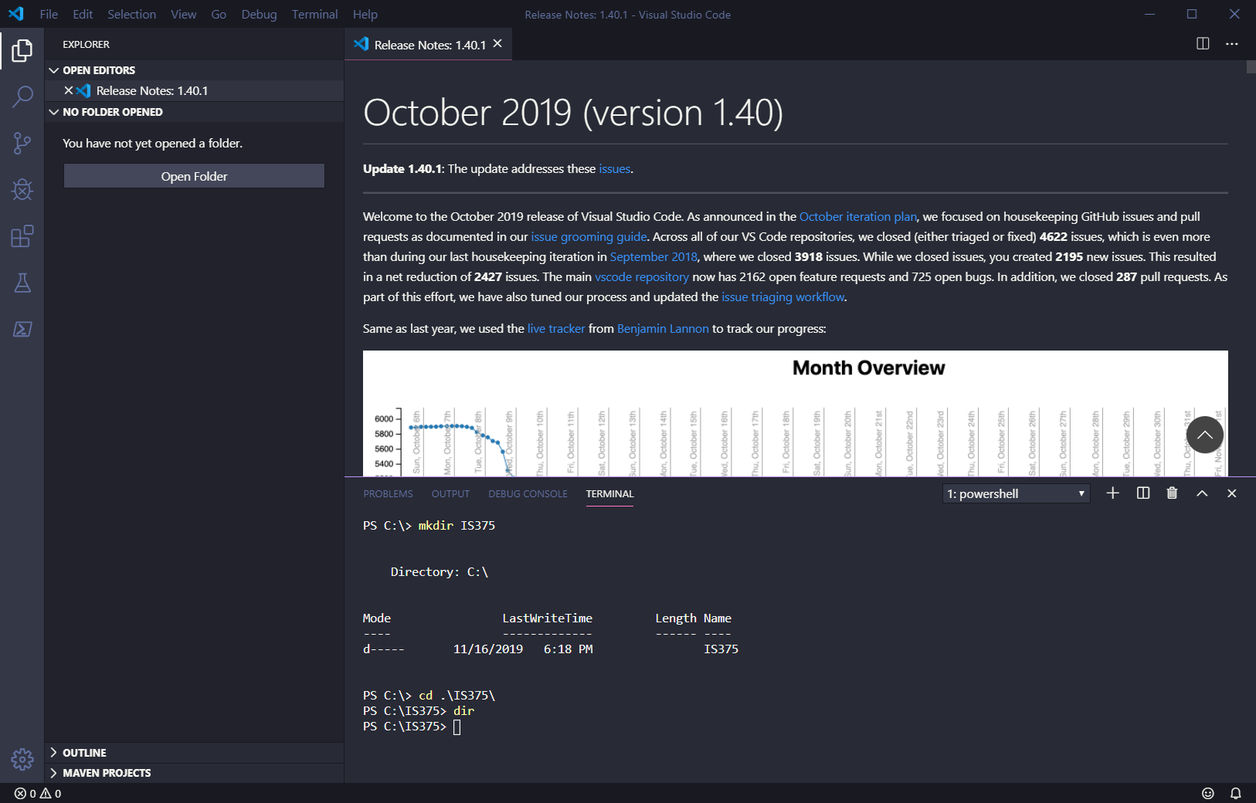

This example uses Windows commands, for macOS users, use commands mentioned above

1. Close the VSCode.

### ENJOY CODING 😄 ###